Bala Subramanya sarma

balasubramanyasarma.scsvmv@gmail.com

**METHODS IN JAVA**

* Methods are the set of statements used to perform a particular task.
* If a method must be executed, it has to be called using its name.

SYNTAX:

return type method Name(parameter)

{

//Definition i.e. body of the method call

}

EXAMPLE:

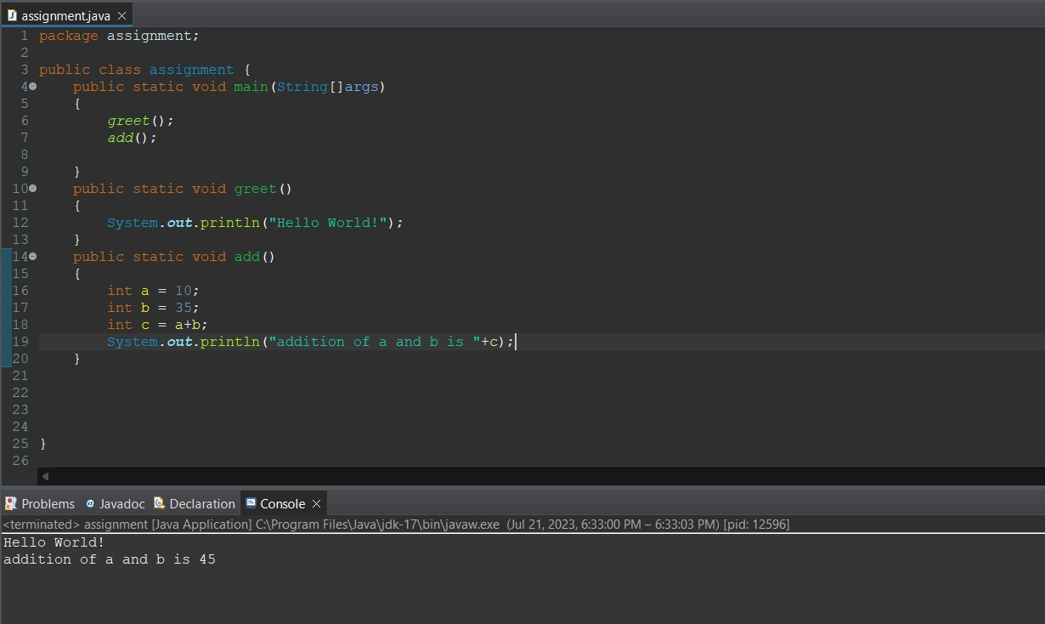

* Based on whether a method is accepting a parameter and returning the value or not. Methods are classified into 4 types they are:-

**TYPE-1 METHOD:**

Methods which would not accept any parameters and would not return any value is known to be type 1 method.

Example:

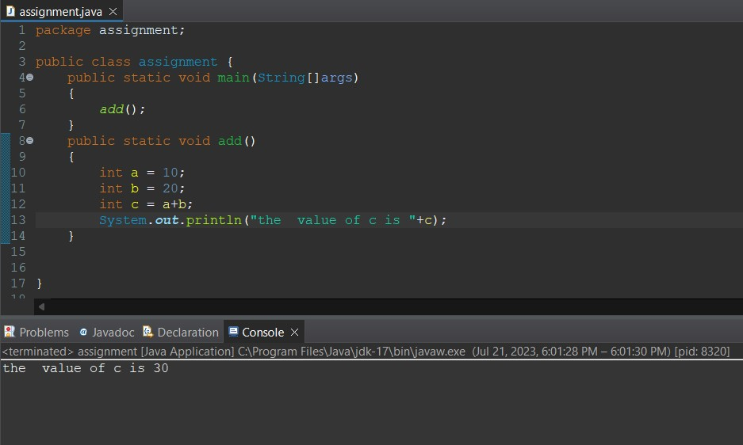

**TYPE-2 METHOD:**

Methods which would not accept any parameters and would return a value is known to be type 2 method.

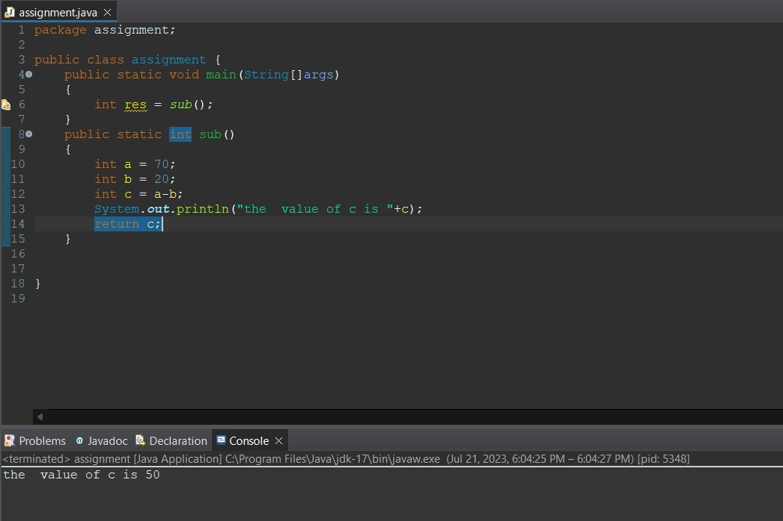

**TYPE-3 METHOD:**

Methods which would accept any parameters and would not return a value is known to be type 3 method.

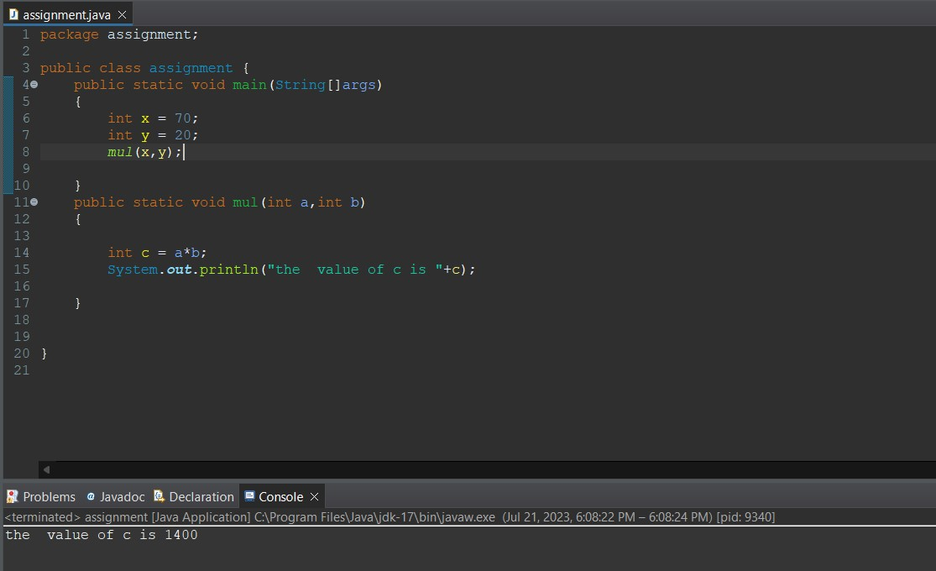

**TYPE-4 METHOD:**

Methods which would accept any parameters and would return a value is known to be type 4 method.

